Saint Leo YOU ELSA
The Embedded Learning Synchronized Assistant (ELSA) allows you to search the library of content available in Saint Leo YOU (powered by Percipio) from anywhere on the web, i.e., articles online, YouTube, etc., without leaving the page. To begin using this feature you must first download the ELSA extension.

Downloading ELSA

- You can download and install the Windows App by clicking here Percipio ELSA download page
- Select either download option:
  - The Chrome Extension was selected for this example
- Once the download is complete, open the ELSA download by clicking .
- Click Next.
- Click Next again.
- Click Install and wait for the installation process to finish.
  - You will receive a popup asking “Do you want to allow this app to make changes to your device?” Click YES.
- After a successful download, you may see the Percipio icon located at the top right side of your browser.
NOTE: If you are using Chrome you will need to “pin” the ELSA extension to the top of your browser window by clicking the and then selecting the pin icon 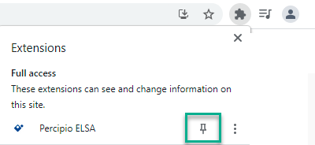
If the ELSA extension is not pinned to the browser, you will have to select it each time you want to utilize this feature.
- Enter the Site Name, saintleo, in the Percipio extension 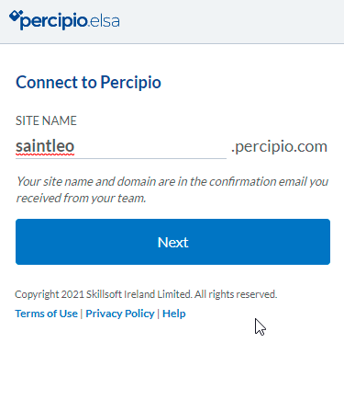.

(Continued)
- Click the “Sign in with corporate credentials” button 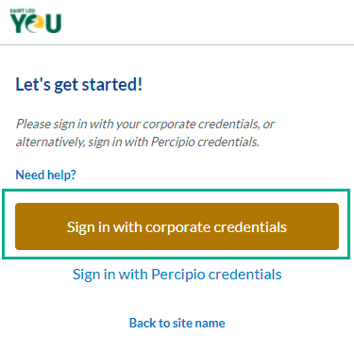.
- Enter your Saint Leo credentials 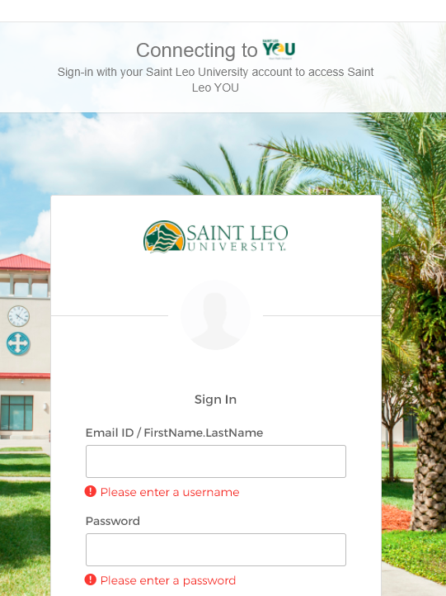 to begin using ELSA.

Using ELSA
Once the ELSA extension is downloaded, and you’ve signed in with your Saint Leo credentials, you can begin using this feature.

In the example shown below, I have come across a phrase “Organizational Culture” in an article I am reading and would like to learn more about it. To do this, follow the steps shown below and see how this feature works:

- Highlight the word you want to learn more about.
- Select “Search in Percipio” 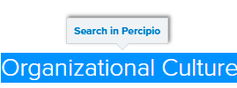.
- If results are available, the Percipio icon will turn green .

(Continued)
- Click the Percipio icon to view the results 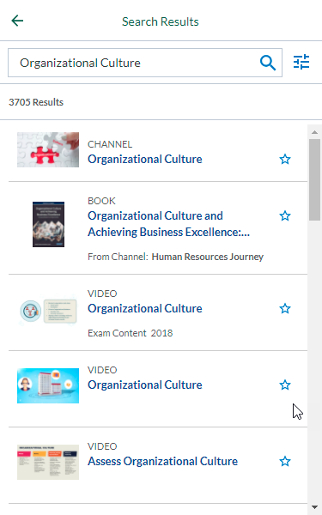.
NOTE: The example above shows 3705 results for Organizational Culture. These results are a mix of books, courses and videos.
- Search results can be filtered using the filter icon . Select the appropriate filter from the list 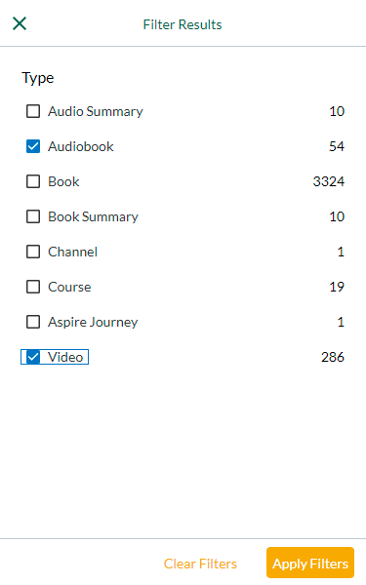 to match your learning needs and click the “Apply Filters” button.

- Select the learning item from the list and it will display in the ELSA window; you don’t even need to leave the page you’re on to consume the learning content.
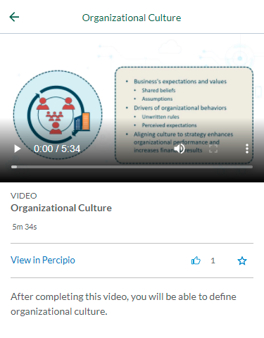
ELSA is designed to play videos and audiobooks. All other learning content, i.e., courses, channels, books, etc., must be viewed in Saint Leo YOU (powered by Percipio) by clicking the View in Percipio link, which will open in a new tab.
(Continued)
- Using the icons shown in ELSA window, you can rate learning and/or add it to your playlist. 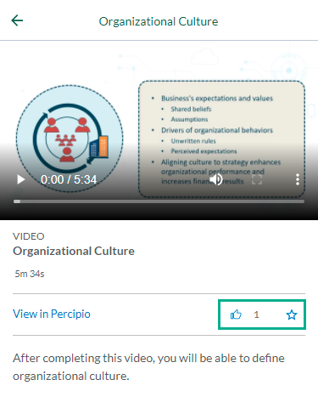

Accessing your existing playlist through ELSA
Using ELSA, you can resume learning content you’ve started and access your saved playlist in Saint Leo YOU.
- Click the ELSA extension to view learning items on Saint Leo YOU 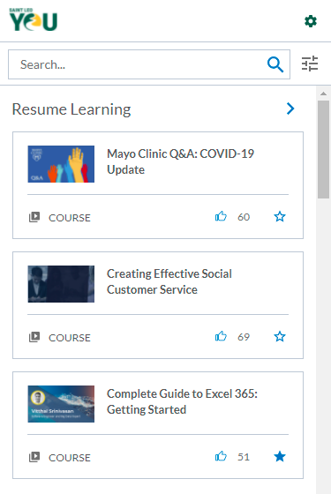.

- Select an item from the list, or click Resume Learning to view learning content 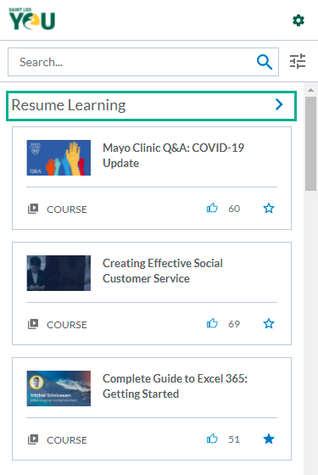.
(Continued)
- Scroll down the ELSA window to view and access your Playlist 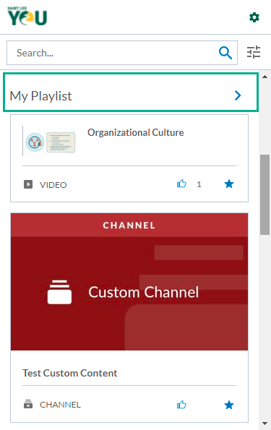.

- You can also start a new search from the ELSA window by typing in keywords in the Search field 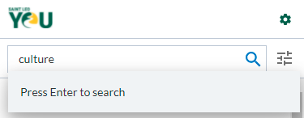 and clicking the search icon (or by clicking enter) 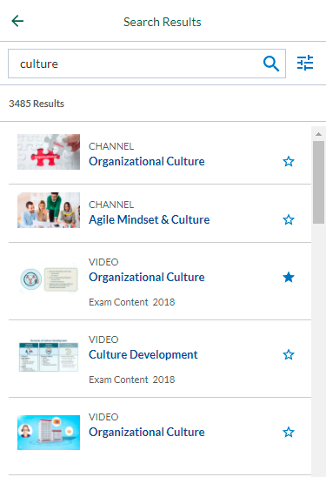 to view results.

