December-January
2019-2020
Holiday Dining Hours
University Meal Plan  The University Meal Plan does not include meals during Thanksgiving or Christmas breaks. However, many students are unable to return home while classes are out of session. As a result, Dining Services is providing a meal option per day except for Thanksgiving Day, Christmas Day, and New Year’s Day. Those who swipe will be able to take a to-go meal in addition to the swiped meal. | 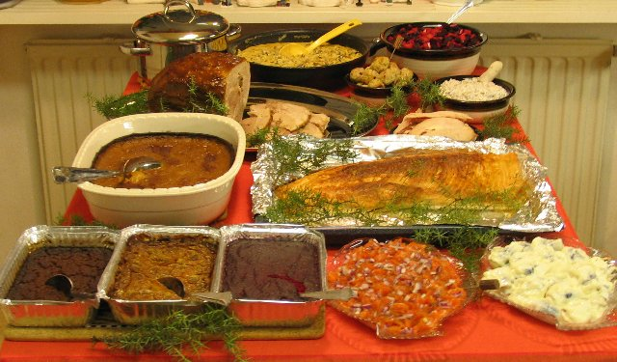
Sunday | Monday | Tuesday | Wednesday | Thursday | Friday | Saturday
1 | 2 | 3 | 4 | 5 | 6 | 7
Lions’ Lair 10 a.m. to 10 p.m.; Dining Hall 4:30 – 6 p.m. | Regular hours | Regular hours | Regular hours | Regular hours | Regular hours | Lair 11-1
8 | 9 | 10 | 11 | 12 | 13 | 14
Lair 11-1 | Dining 11am-1pm | Dining 11am-1pm | Benedict’s 7:30am-4pm;  Dining 11am-1pm | Benedict’s 7:30am-4pm;  Dining 11am-1pm | Benedict’s 7:30am-4pm;  Dining 11am-1pm | Lair 11-1
15 | 16 | 17 | 18 | 19 | 20 | 21
Lair 11-1 | Benedict’s 7:30am-4pm;  Dining 11am-1pm | Benedict’s 7:30am-4pm;  Dining 11am-1pm | Benedict’s 7:30am-4pm;  Dining 11am-1pm | Benedict’s 7:30am-4pm;  Dining 11am-1pm | Benedict’s 7:30am-noon  Faculty/Staff Christmas Party | Lair 11-1
22 | 23 | 24 | 25 | 26 | 27 | 28
Lair 11-1 | Dining 11am-1pm  Benedict’s 7:30am-Noon | Dining 11am-1pm  Benedict’s 7:30am-Noon | Closed | Dining 11am-1pm  Benedict’s 7:30am-Noon | Dining 11am-1pm  Benedict’s 7:30am-Noon | Lair 11-1
29 | 30 | 31 | 1 | 2 | 3 | 4
Lair 11-1 | Lair 11am-1pm  Benedict’s 7:30am-Noon | Lair 11am-1pm | JANUARY  Closed | Benedict’s 7:30am-4pm;  Dining 11am-1pm | Benedict’s 7:30am-4pm;  Dining 11am-1pm | Lair 11-1
5 | 6 | 7 | 8 | 9 | 10 | 11
Lair 11-1 | Benedict’s 7:30am-4pm;  Dining 11am-1pm | Benedict’s 7:30am-4pm;  Dining 11am-1pm | Benedict’s 7:30am-4pm;  Dining 11am-1pm | Benedict’s 7:30am-4pm;  Dining 11am-1pm | Benedict’s 7:30am-4pm;  Dining 11am-1pm | Lair 11-1
January 12: regular operating hours
January 13: Benedict’s Grand Opening, 10 a.m. Everyone Welcome! (open 10 am until midnight)
January 14: Benedict’s regular hours begin- open 7am to midnight, seven days a week

