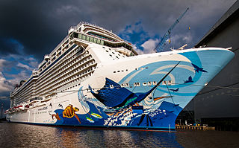
Norwegian Escape
October 21– 28, 2017
Saint Leo University
Class Learning at Sea Program

Day | Ports of Call | Arrival | Departure
Saturday, 10/21/17 | Miami  (Tour of Miami’s US Customs Station)  12:00 – 1:30 PM  (Class Orientation)  2:00 PM – 4:00 PM | -- | 4:00 PM
Sunday, 10/22/17 | At Sea (Class 9:00 AM – 4:00 PM) | -- | --
Monday, 10/23/17 | At Sea (Class 9:00 AM - 12:00 PM) | -- | --
Tuesday, 10/24/17 | St. Thomas  (Tour of US Coast Guard Station and Vessels in St. Thomas along with resident Federal Customs and FBI agents class presentation)  9:00 AM – 1:00 PM | 8:00 AM | 6:00 PM
Wednesday, 10/25/17 | Tortola, VI | 7:00am | 3:00pm
Thursday, 10/26/17 | At Sea (Class 9:00 AM – 12:00 PM) | -- | --
Friday, 10/27/17 | Nassau | 12:00pm | 7:00pm
Saturday, 10/28/17 | Miami | 6:00 AM | --
Prices includes: Port charges and taxes.
NCL reserves the right to institute a fuel surcharge at their discretion at any time including after final payment.

FINAL PAYMENT: Final payment is due October 1, 2017.

CANCELLATION PENALTIES: There is no penalty for cancellation from time of deposit until 70 days prior to departure. For cancellation from 70 to 56 days before departure the deposit is non-refundable. For cancellation from 55 to 30 days before departure the penalty is 50% of the total price per person. For cancellation from 29 to 15 days before departure the penalty is 75% of the total price per person. For cancellation within 14 days of departure the penalty is 100% of the total price per person.

Cruise Price: Please contact Amy Post at (386) 383-2472 or amypost@postcardtravelplanning.com for current pricing.

Category Double Single
MC- Mini Suite 2871.00 N/A
BB –balcony 2517.70 2335.00
OV-Ocean View 2297.70 N/A
ID-inside 1932.86 N/A
T1- Studio N/A 1366.43

Prices subject to change without notice.
Note: Prices for all rooms are based on prices
and availability at time of booking.

Please call for pricing for Triple and Quad rooms.

**LAST DATE TO BOOK: October 1st, 2017**

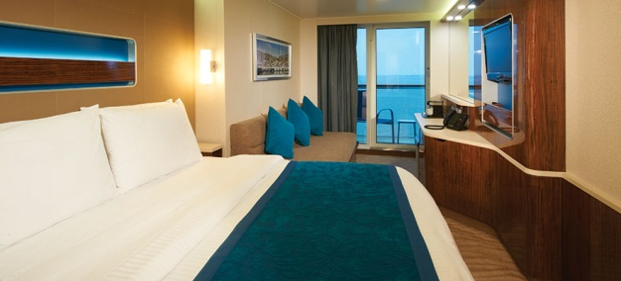
The Norwegian Escape Highlights
- Stroll along a revolutionary, quarter-mile oceanfront walkway, enjoy treats from Carlos Bake Shop.
- Norwegian Escape offers many unique dining experiences. More than any other cruise line.
- Our flexible accommodations feature a world of comfort whether it’s a studio made for the solo guest or connecting staterooms ideal for families.
- Chill out in the Ice Bar. Find your lucky slot machine in our casino. Or go dancing till the wee hours at Bliss Ultra Lounge.

What’s Included
- Complimentary dining options are available on board Norwegian Escape, from three-course dining to endless buffets with action stations.
- Broadway shows, jazz & blues clubs, and the Headliners Comedy Club
- Fitness center, mini golf, sports court, ropes course, rock climbing wall, aqua park, pools, and hot tubs.
- Youth programs for children ages 3-17.
- Attentive room steward and complimentary room service.
- And much more!!
Stateroom Categories
Category MC – Mini Suite with Balcony
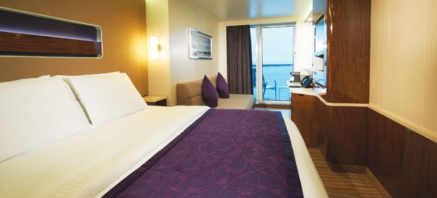

Ideal for the whole family, these staterooms are conveniently located near the kids’ area and include two lower beds that convert to a queen-size bed, an upper bed and a sofa bed. Accommodates: 2-4

Category BC & BF – Balcony

Floor-to-ceiling glass doors open to a private balcony with sweeping views. So enjoy beautiful sunrises, breathtaking sunsets and a cozy and comfortable room designed with you in mind. Accommodates: 2-4
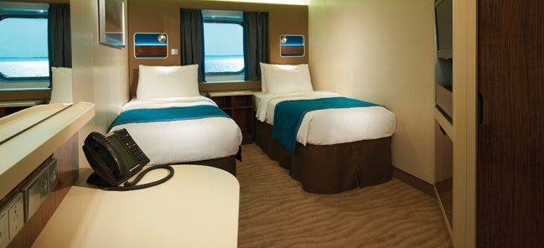
Category ** – Oceanview

(not available for this sailing)

Category ID– Inside

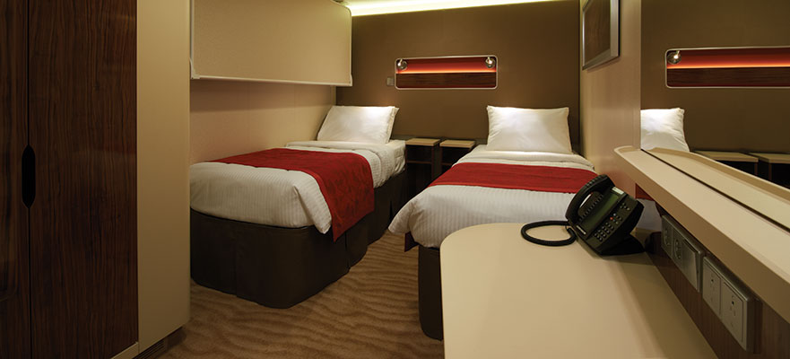
These staterooms feature a large picture window and two lower beds that convert to a queen-size bed. Accommodates: 2-4

Studio – inside, for the solo traveler

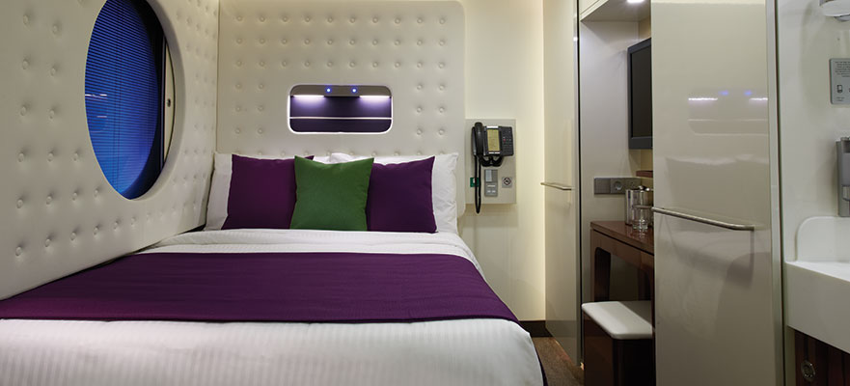
Private keycard access complex comprised of staterooms specifically designed and priced for the solo traveler. Featuring a full-size bed, a one-way window to the corridor, and separate areas for your bathroom, sink and shower. Includes access to the private Studio Lounge. Accommodates: 1.

St. Leo University 2017
Oct. 21st – 28th

Legal Name 1:___________________________________________________________________________

Legal Name 2:___________________________________________________________________________

Address__________________________________________________________________________________

City_________________________________State__________________Zip____________________________

Telephone_______________________

Secondary Address_________________________________________________________________________

City_________________________________State__________________Zip____________________________

Telephone_______________________ Email address:______________________________________________

Date of Birth – Name 1:_____________________________ Name 2:______________________________

Emergency Contact: Name:_______________________________________________Relationship:_____________________

Emergency Contact Phone: Daytime__________________________________Evening________________________________

Dining preference on the ship for Dinner: Group dining_______ Other_______

Stateroom Category: 1st choice________2nd choice________ Bed preference: Queen_____ Twins_____

T-shirt size: Name 1 - S___ M___ L___XL___XXL___ Name 2 – S___M___L___XL___XXL___

For deposit: $250 per person payable by credit card.

Credit Card Type_____ Card #_______________________________________Exp. Date______________

Name as it appears on the credit card_______________________________________________

Signature_______________________________________________Date____________________
For Office use only

Conf # _______________

Cat____ Stateroom______

Deposit $______________

Deposit Date___________
Return this completed form with deposit to:
PostCard Travel Planning
4701 Inisheer Court
Tallahassee, FL 32309
Ph: 386-383-2472
Email: amypost@postcardtravelplanning.com

STEPS:

- Contact Amy Post to secure your deposit for the cruise:
Amy Post (386) 383-2472
amypost@postcardtravelplanning.com
- Once registered with Amy, contact Karin May to register for class.

